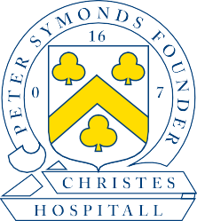
Peter Symonds College
Principal: Sara Russell

IN CONFIDENCE

Application to be considered as a Governor of the College

All personal details provided will be kept confidential. Please save and complete this form along with the Equality & Diversity Monitoring form, then email to vowen@psc.ac.uk with “Application to become a governor” as the subject. Please complete and sign the Eligibility form and bring it with you if you are invited to progress your application further.

Name
Address
Telephone Number
Mobile
Email
Name of Child at PSC  (where applicable) |  | Tutor Group

Please state whether to the best of your knowledge you are related to a Governor or any member of staff at Peter Symonds College. If so, please state the nature of the relationship and the name of the governor or employee at the College.

If you have a disability or condition that you would like us to consider then please give details of any special arrangements you would require to attend an interview.

Occupation or Experience (please also attach a copy of your current CV)

When responding, could you please indicate if you have any skills or experience in any of the following areas:
- Health & Safety
- Child Protection/Safeguarding
- Finance
- Audit
- Education
- HR
- Political processes
- Estates (Planning/Building and/or Procurement)
- Equality & Diversity
- Sustainability

What particular contributions will you make to the Board?

